1. **PURPOSE:** To Describe safe inspection &Certification of Air receivers in the plant for safe operation
2. **SCOPE:** Battery-1, Battery 2 & Jetty
3. **RESPONSIBILITY:** Engineer in charge and Maintenance fitter on the job.
4. **SAFETY PRECAUTIONS:**
   * Ensure all Process, Electrical & Mechanical isolation prior to starting work on equipment. Follow documented isolation procedure as per Vedanta approved isolation standards.
   * Obtain Proper work permit
   * Job to be carried out by Competent Person authorized by Inspector of Factories & Boilers .
   * Safety briefing / Toolbox talk to be carried out and to be documented
   * Follow one man one lock system and use of LOTO box.
   * Ensure that workplace is clean and safe.
   * Remove mechanical isolations(Blanking of flanges with dummy flange) after completion of testing job.
   * All unwanted material from the area to be removed before releasing the equipment electrical isolation.
   * Follow proper documented procedure for releasing the electrical isolations as per Vedanta approved isolation standards.
5. **PPE to be used :**
   * Safety Helmet
   * Safety shoes
   * Safety Goggles
   * Hand gloves
   * Dust mask
   * Safety belt/Harness
   * Reflector jacket.
6. **BASIC COMPONENTS**

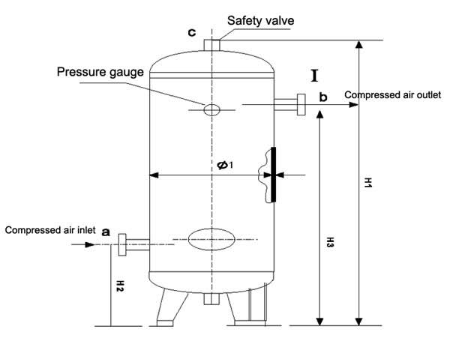

Drain valve

Manhole

Components

1. Air Inlet Pipeline
2. Air Outlet pipeline
3. Safety valve
4. Manhole
5. Drain valve
6. Pressure gauge
7. **Activities**

* Activity No 1 : External Examination of Pressure vessels
* Activity No 2 : Internal Examination of Pressure vessels
* Activity No 3 : Ultrasonic Examination of Pressure vessels

1. **Aspect-Impact:**

* Scrap generation Resource Depletion.
* Dust Generation Air Pollution.
* Fire Hazard Air Pollution.

1. **Hazards** **identified**
2. Physical Hazard

* Fall of dust in ears, eyes, mouth
* Air Pressure

1. Mechanical Hazard

* Fall of material like hammer, tools, slung items, bolts etc
* Fall of person from monkey ladder
* Fall of pressure testing accessories

1. Human behaviour aspect of operators:

* Alcoholism.
* Casual approach.
* Horse play.
* Non usage of PPE’s
* Improper Housekeeping
* Height Phobia

**Activity No 1: External Examination of Pressure vessel (Frequency: Every 6 months)**

The approved agency from *Inspector of Factories & Boilers* will carry out the inspection

* + External visual inspection of air receiver will be carried out every 6 months to check condition of Pressure relief valve, Safety valve, functioning of gauges, air leakage, and condition of paint/corrosion if any.
  + Certified ladder shall be used to access the points above 1m from ground level
  + Any abnormal observation to be immediately reported to area engineer for correction by the inspecting agency.
  + Write the *certification details* on the air receiver with *date of certification & next due date.*

**Activity No 2: Internal Examination of Pressure vessel (Frequency: Every 2 years)**

* + Internal examination is to be carried out every 2 years as per Factory act, Hence **Hydraulic examination(use of water)** is carried out by designated person.
  + The designated air receiver shall be isolated from service for Hydraulic testing after taking work permit from production department. Intimate User department in advance.
  + Barricade the area near air receiver.
  + Release the air from air receiver by *opening drain valve* at the bottom of air receiver standing away from the valve.
  + All safety items, gauges, fittings shall be inspected and replaced if required.
  + Use *certified* safety belt/harness while working at height while checking/replacing the gauges. Do not keep the tools, gauges hanging on the structure while working.
  + Blank the *inlet and outlet pipe*line flanges and fill the air receiver with *water*.
  + Set the safety valve to *1.5 times of operating pressure* for testing.
  + Stay away from air receiver during hydraulic testing.
  + Now connect hand pump with help of hose and pressurize to 1.5 times of operating pressure by looking at pressure gauge. Keep the pump at least 5 meters away and operate hand pump.
  + Keep all men away during hydraulic testing.
  + Check for drop in pressure from *Pressure gauge* and leakage to the satisfaction of inspector.
  + De-pressurize the air receiver by draining the water from drain pipe and then remove the blanks and bolt to the system.
  + Set the *relief valve* to 1.1 times of operating pressure.
  + Connect the air receiver with the permission of User department and release it for service. Clear work permit & shutdown of compressor.
  + Write the certification details on the air receiver with date of certification & next due date.
  + Carry out the housekeeping activity after completion of the job.

**Activity No 3: Ultrasonic Examination of Pressure vessel (Frequency: Every 2 years)**

The approved agency of Goa Factory Inspector will carry out the inspection

* + The *thickness* of shell will be checked with *calibrated thickness gauge* brought by the agency at pre-designated points on the air receiver *without isolating the air receiver.*
  + Obtain work permit from production department.
  + Barricade the area near air receiver.
  + Use safety belt/harness while working at height while checking/replacing the gauges. Do not keep the tools, gauges hanging on the structure while working.
  + Write the *certification details* on the air receiver with *date of certification & next due date.*

1. **REFERENCES:**

* Factories Act,1948, Section 7A: General duties of occupier
* Goa Factory Act-1968, Section 31

**11.0 RECORDS:**

|  |  |  |  |  |  |
| --- | --- | --- | --- | --- | --- |
| **Sr. No.** | **Record No.** | **Record Title** | **Maintained by** | **Soft/Hard form** | **Retention Time** |
| 1. | HI/MAINT/47 | Hazard Identification | IMS | Soft | 1 Yr. |
| 2. | RA/MAINT/47 | Risk Assessment | IMS | Soft | 1 Yr. |



|  |  |  |  |
| --- | --- | --- | --- |
| **Date** | **Manual Section Ref. & Para** | **Brief details of Revision** | **New Rev.** |
| 13-08-2022 | Header | Company logo & Document no. | 06 |
|  |  |  |  |
|  |  |  |  |

|  |  |  |
| --- | --- | --- |
| **Prepared By:**  Head Mechanical Maintenance, Battery 1- MCD | **Reviewed & Issued By:**  Management Representative | **Approved By:**  Head Mechanical Maintenance MCD |
| **Signature:** | **Signature:** | **Signature:** |
| **Review Date: 13.08.2022** | **Review Date: 13.08.2022** | **Review Date: 13.08.2022** |